# Install a per tenant extension in Microsoft Dynamics 365 Business Central

Open Business Central. Go to Extension Management

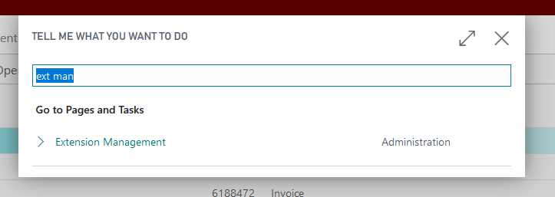

In Extension Management select Manage > Import Extension

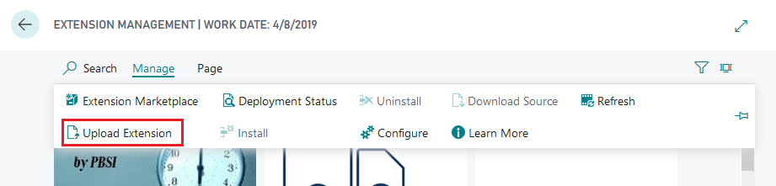

In the Upload and Deploy Extension page that opens select the .app file and accept the disclaimer. When done click Deploy.

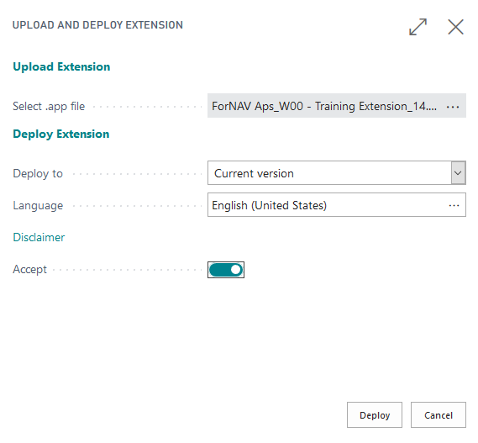

# To remove the extension from Business Central

Removing extensions in the Business Central tenant has one downside, the extension data cannot ever be removed. That means you can uninstall and reinstall an extension without data loss.

To remove an extension, go to Extension Management and find the extension you want to remove. Open the More Options menu and select Uninstall. Confirm the uninstallation.

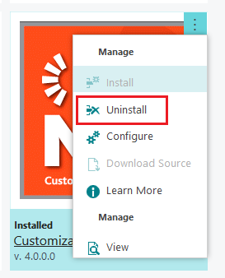

Uninstalling the extension disables it. To remove it completely open the More Options menu again and select Unpublish.